

**Disclaimer: The content is curated from online/offline resources and used for educational purpose only**



**LAB MANUAL**

**Unit I – Foundation of Green Skilling, Sustainability and AI Contributions**

**Unit I – Foundation of Green Skilling, Sustainability and AI Contributions**

**Lab - 3**

**Case Study: Green Skilling for Sustainable Energy Transition**

**Introduction:**

Transitioning to sustainable energy systems is critical to mitigate the effects of climate change, reduce dependence on fossil fuel, and make the global energy infrastructure more resilient. Green skilling is a vital component for such a transformation. GSDP and similar initiatives can help equip the workforce with the right skills required to support renewable energy projects and make a critical contribution to furthering energy efficiency and spreading clean energy solutions.

With increasing demand for sources of renewable energy, the growing demand in solar, wind, and bioenergy, there exists an immediate need for competent and skilled construction of a workforce. Green skilling bridges the gap by providing specialized training, thereby contributing to the design, installation, maintenance, and management of renewable energy systems.

**Key Initiatives:**

Among several initiatives taken by the Indian government to meet the ever-growing demand for skilled labor in the renewable energy sector, there comes the Green Skill Development Programme. Launched by the Ministry of Environment, Forest, and Climate Change, MoEF&CC, the GSDP aims to train the young and the professional masses of India with green skills. GSDP focuses on the issues of sustainable development pertaining to multiple sectors, namely energy.

**Key Initiatives in Green Skilling for Energy Transition:**

* **Solar PV Technician Training:** Focuses on equipping workers with the skills to install, maintain, and monitor solar photovoltaic (PV) systems, which are widely adopted in India.
* **Wind Energy Technician Training:** Provides training on the operation and maintenance of wind turbines, an essential part of India's clean energy push.
* **Energy Auditors and Managers:** These professionals are trained to evaluate energy use and improve energy efficiency in industries and buildings, contributing to the overall reduction in energy consumption and emissions.

The GSDP also partners with institutions, universities, and renewable energy companies to ensure that the training is practical and industry-aligned, preparing the participants for real-world challenges.

Table: Key Initiatives in Green Skilling for Energy Transition and Technologies Used

| **Initiative Name** | **Aim** | **Objective** | **Start Date** | **End Date** | **Location** | **Technology Used** |
| --- | --- | --- | --- | --- | --- | --- |
| **Solar PV Technician Training** | Train individuals in solar PV installation and maintenance | Equip technicians with skills to install, monitor, and maintain solar photovoltaic systems | Jan 2022 | Ongoing | Rajasthan, Gujarat, Tamil Nadu | Solar PV panels, inverters, grid systems |
| **Wind Energy Technician Training** | Develop skills for wind turbine operations | Train technicians for operating and maintaining wind turbines in growing wind energy sectors | March 2021 | Ongoing | Gujarat, Tamil Nadu | Wind turbines, control systems, SCADA |
| **Energy Auditors and Managers** | Enhance energy efficiency in industries and buildings | Develop expertise in energy auditing, grid management, and energy conservation to reduce energy waste | Feb 2020 | Ongoing | Pan India | Energy management software, smart meters |
| **Bioenergy Specialist Training** | Promote the use of bioenergy technologies | Train individuals on bioenergy production, waste-to-energy processes, and biomass energy systems | July 2021 | Ongoing | Maharashtra, Karnataka | Biomass conversion, bio-digesters, biogas |
| **Smart Grid and Battery Storage** | Develop skills for smart grid and energy storage | Equip professionals with knowledge of smart grid systems and energy storage solutions | April 2022 | Ongoing | Delhi NCR, Karnataka | Smart grid systems, energy storage batteries |
| **Green Building Technician Training** | Promote energy efficiency in building sectors | Train individuals in the installation of smart meters, energy-efficient lighting, and HVAC systems | Sept 2021 | Ongoing | Maharashtra, Kerala | Smart meters, LED lighting, HVAC automation |

**Objectives:**

The objectives of green skilling initiatives for sustainable energy transitions are wide-ranging and focus on both environmental and economic benefits. Key objectives include:

1. **Skilled workforce:** Instruction in core technical skills for professionals entering the renewable energy sectors, including solar power, wind power, bioenergy, and hydroelectric systems.
2. **Promote energy efficiency:** Instruction equips professionals with core knowledge and tools to audit and improve energy use-cut waste, improve energy efficiency across sectors.
3. **Support Employment in Renewable Energy:** Jobs on new and new growing renewable clean energy markets; installation of new and enlarged solar projects in rural installations to big ones in the wind offshore farms.
4. **Fostering Innovation:** Train individuals in the latest smart grids, in battery storage systems, and energy management software, to foster the development of new technologies and energy solutions.
5. **Supporting National and Global Goals:** Building human capital which could help India accomplish ambitious targets for renewable energy while supporting India's commitments under global agreements, such as the Paris Agreement.

**Implementation:**

The implementation of green skilling programs for sustainable energy transitions is a multi-faceted effort involving:

1. **Collaborations:** GSDP collaborates with government institutions like the Ministry of New and Renewable Energy (MNRE), private companies, and educational institutions to design complete training programs.
2. **Modular Courses:** Trainings are designed in the form of modular courses at various skill levels, starting from basic technician courses to advanced energy auditing programs. These are often short, practical courses which the trainee undertakes.
3. **Location-Specific Training:** Considering the varied geographic needs of renewable energy projects, training centres are in areas where renewable energy projects are being actively deployed. For instance, solar PV training is conducted at the locations of Rajasthan and Gujarat states, which have seen most of the action on solar energy projects.
4. **Utilization of Technology:** Virtual labs, simulation tools, and distance learning platforms are provided so that training could be made accessible to remote areas. Through these tools, trainees can work around the world with cutting-edge energy systems and software's, and no physical kind of infrastructural setup is required.

1. **Partnerships with Industry Leaders:** Such partnerships ensure training that is current in the market for industries and supplements learning by experience through internships and on-site training.

**Outcomes:**

Green skilling programs have yielded significant outcomes in terms of employment, energy efficiency improvements, and environmental benefits:

1. **Job creation:** This has trained thousands of people; hence, they are now gainfully employed in renewable energy. Some of the people's careers include solar installation, wind turbine maintenance, and even energy efficiency auditing.
2. **Improved Energy Efficiency:** The industries and businesses have been managed and audited by skilled auditors and managers. This means that cost saving will be improved, and carbon emissions will also be reduced.
3. **Scale and Deployment of Renewable Energy Projects:** The availability of trained technicians has not only pushed up the roll-out of renewable energy projects but has also opened up areas within the country for clean energy, especially in remote and disadvantaged regions.
4. **Economic and Social Returns:** The programs have had direct contributions to environmental mitigation but have also enhanced the living standards of participants, who are mostly rural youths, through job security in clean energy-related sectors.

**Challenges and Opportunities:**

While the success of green skilling programs is evident, several challenges remain:

1. **Infrastructure Development:** There is a need to develop the physical training centers and equipment in remote areas.
2. **Awareness:** Most communities and potential workers are yet to be informed about renewable energy and sustainable practice careers.
3. **Foundation of Resources:** Sustainability funding models have to be established up-scale this kind of training and ensure long term sustainability.

Despite these challenges, however, the future for green skilling initiatives is bright. Global efforts toward decarbonization and growing dependence on renewable energy translate into large opportunities both to expand training programs and to green job creation.

**Success Stories:**

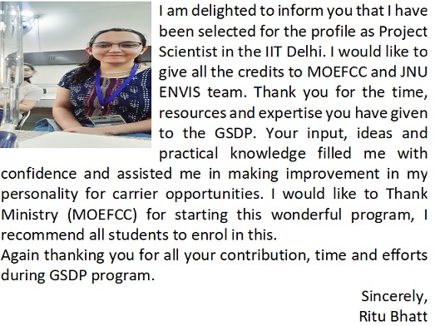 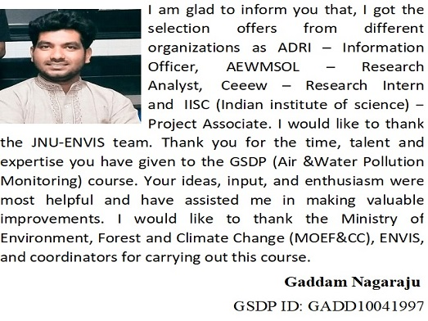

**Introduction to Specialized Green Skill Development Courses**

The need to develop expertise has never been higher in the arena of environmental conservation, given that today's world is dramatically challenged in climate change, biodiversity loss, and pollution. The certificate courses specialize on such topics as biodiversity conservation, covering full spectra of topics from pollution monitoring courses to active contribution to sustainable development and environmental protection.

Among the many essential areas of focus are:

* **Bird Identification and Ornithology**, which fosters an understanding of bird species and their ecological roles.



* **Bird Migration Studies**, aimed at tracking and protecting migratory bird populations, crucial for maintaining biodiversity.



* **Pollution Monitoring**, an indispensable skill for evaluating the quality of air and water and mitigating harmful pollutants.

These courses not only cater to individuals passionate about environmental science but also create a pathway for professionals seeking to contribute to the global sustainability movement.

**Conclusion:**

Green skilling is imperative for catalysing a sustainable energy transition, as the workforce is expected to expand and become capable of supporting growth in renewable energy technologies. This increase in scale of solar, wind, and bioenergy projects means that the required skilled workforce is needed to manage, install, and maintain those systems. Initiatives like GSDP are really important in empowering the population with such skills and knowledge to be part of this transformation and realize the economic, environmental, and social benefits for the future. Continued investment in green skills, partnership with industry leaders, and accessibility and funding challenges will be defining pillars in the pursuit towards the realization of sustainable energy goals.